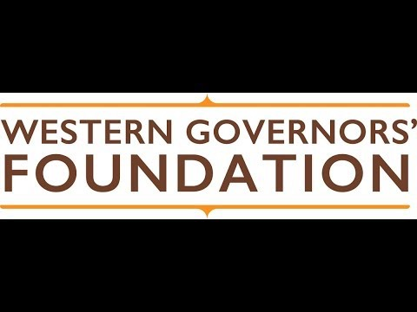`

**Western Governors’ Leadership Institute**

Application

Thank you for applying to the Western Governors’ Leadership Institute.

The Western Governors’ Leadership Institute is a project of the Western Governors’ Foundation. The program is designed to recognize, reward, and promote the effective exercise of leadership by young adults across the West.

Every year, the institute selects young adults to represent western states, territories, and tribes as institute delegates. Delegates attend the Annual Meeting of the Western Governors’ Association, as well as a one-day leadership development forum. The foundation covers all expenses associated with delegate participation.

The 2025 leadership forum will take place in Santa Fe, New Mexico on June 22, followed by the Western Governors’ Association Annual Meeting, June 23 – June 25.

**Eligibility**

* To be eligible, an applicant must be a permanent resident of: Alaska, American Samoa, Arizona, California, Colorado, Guam, Hawaii, Idaho, Kansas, Montana, Nevada, New Mexico, North Dakota, Northern Mariana Islands, Oklahoma, Oregon, South Dakota, Utah, Washington, or Wyoming. Alternatively, candidates who are enrolled members of state or federally recognized tribes and residing in the West may apply to represent their tribes.
* Eligible applicants must be between the ages of 21 and 26 years old on June 22, 2025

**How to apply**

Step 1:  **Submit a completed application to [jogsbury@westgov.org](mailto:jogsbury@westgov.org) by February 7, 2025.** The subject line should read: “2025 WGLI Application [Last Name] [Your State].” Please submit all materials in a Word or PDF file format.

Step 2: Two letters of recommendation from individuals not related to you must be **submitted by February 7, 2025, to [jogsbury@westgov.org](mailto:jogsbury@westgov.org)**. These letters should be sent directly from your references. They should be written by individuals who know you well and are qualified to speak to your character, leadership qualities, and future potential. Please ask your references to submit all materials in a Word or PDF file format.The subject line should read: “WGLI LOR for [full name of applicant].”

*For questions about the program, please email Anna Caplan at acaplan@westgov.org.*

|  |
| --- |
| Applicant Information |

Name_______________________________________________________ Date of birth ___/____/___

First Last M.I.

Mailing Address__________________________________________________ _____________

Street Address APT #

_____________________________________________________________________________

City State or Territory Zip Code

Phone ____________________ Email ______________________

☐  If you are an enrolled member of a state or federally recognized tribe and are applying to represent your tribe, please check this box and identify your tribe in the space below.

Tribe ________________________________________

Biographical Statement

Please provide a brief biographical statement that speaks to your identity, passions, and aspirations. Discuss instances in which you have demonstrated leadership or overcome challenging obstacles. (150-300 words)

Education

Please list secondary and post-secondary academic institutions you have attended. Please include dates attended, degrees conferred, and academic awards, scholarships, and accomplishments. Use such space as you require.

Work and Community Service Experience

Please detail your employment history, including dates of employment and principal responsibilities, as well as community service activities, charitable organizations, or philanthropic efforts with which you are or have been involved. Under work history, please feel free to include professional certifications, accomplishments, and commendations. Under community service, discuss formal leadership roles you have held or ways in which you have otherwise exercised leadership to benefit your community. Use such space as you require.

Interests and Avocations

Please discuss your personal interests (including hobbies and extracurricular activities) not otherwise addressed above. Include awards, accomplishments, and special recognition. Use such space as you require.

Short Response

*Please describe your success at negotiating a successful solution to a thorny problem, or otherwise bringing people together to resolve a conflict. 150-200 words.*

Leadership

*What does leadership mean to you? Why should you be selected to represent your state or territory at the Western Governors’ Leadership Institute? 350-700 words.*